Xero API (Postman)

Step 1: Import the Xero OAuth2.0 collection and Xero environment into Postman.

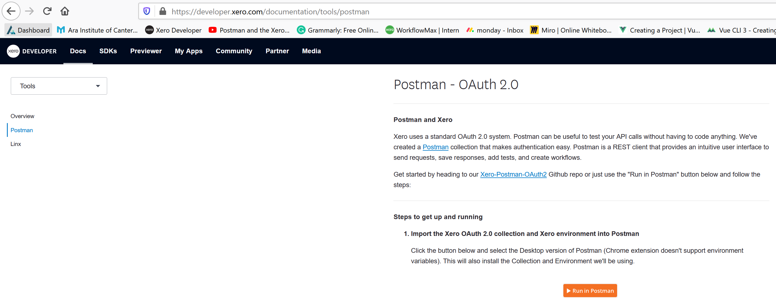

Note: SDK-A software development kit (**SDK**) is a collection of software development tools in one installable package. They ease creation of applications by having compiler, debugger and perhaps a software framework.

Step 2: Create a new app

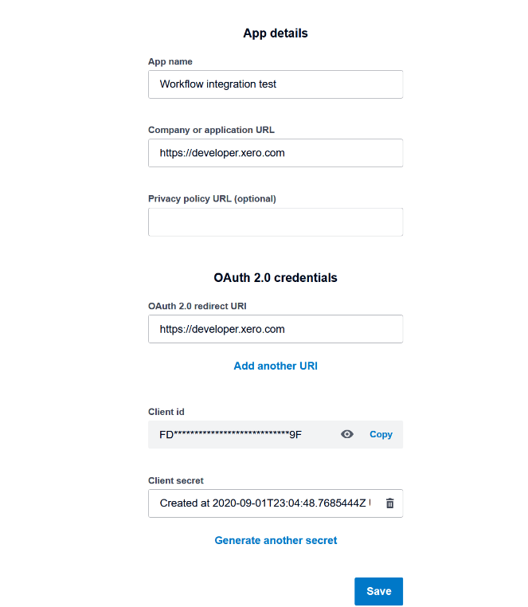<https://developer.xero.com/myapps/>

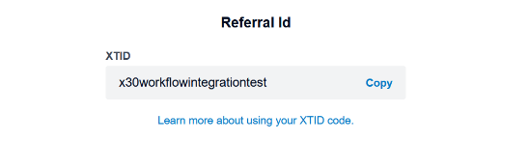

Step 3: Manage Environments:

Scopes: <https://developer.xero.com/documentation/oauth2/scopes>

Xero: offline_access openid profile email accounting.transactions

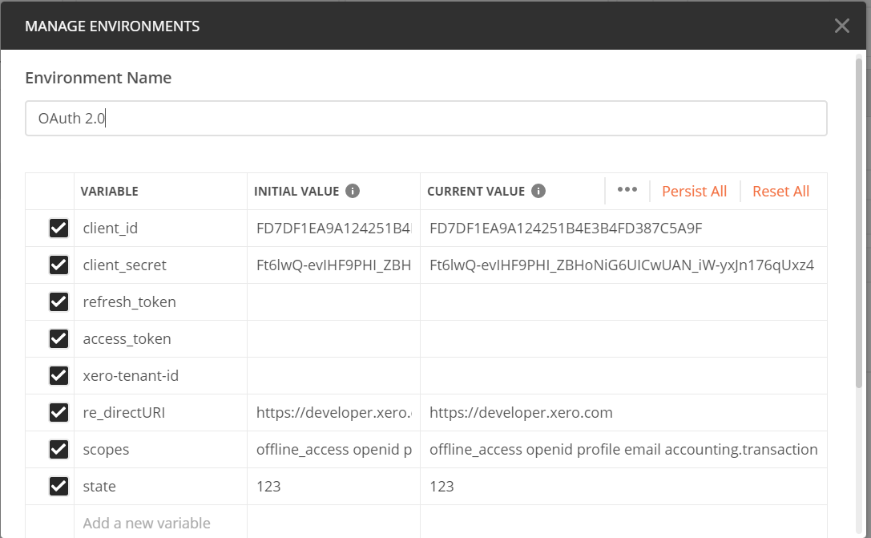

Step 4: Request token

Postman—Xero OAuth 2.0 – Get started – Authorization – Get New Access Token

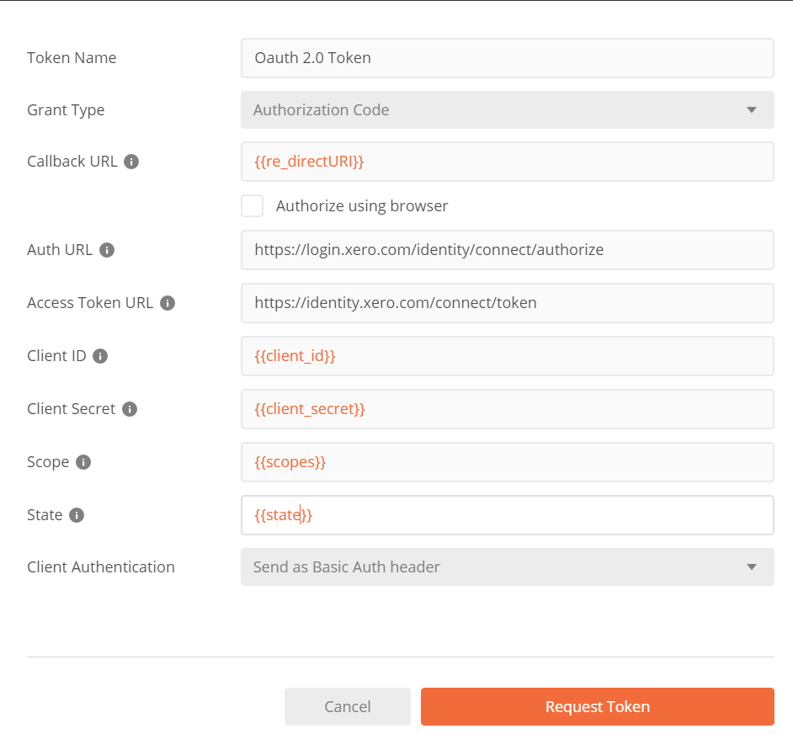

Access token – Highlight whole thing --Right click ‘Set OAuth 2.0’– Choose ‘access_token’；

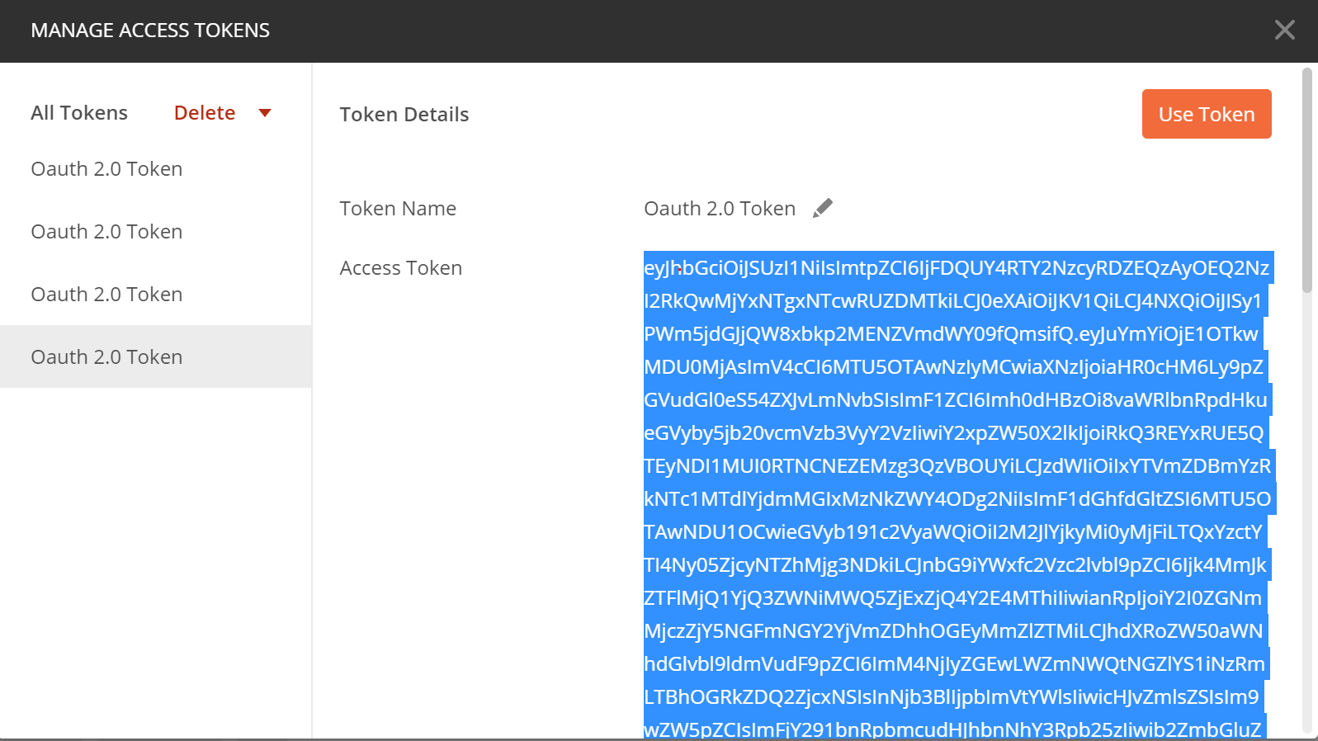

Refresh token – Highlight whole thing -- Right click ‘Set OAuth 2.0’ – Choose ‘refresh_token’.

Step 5: Refresh token – Send: Refresh both access_token &refresh_token.

Step 6: Connections

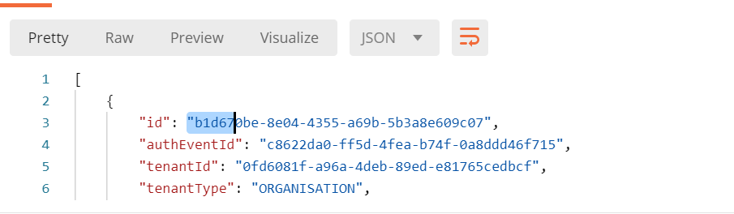

Step 7: copy tenantID to environment.

**Note:** Id: Can be used to remove the connection from my end.

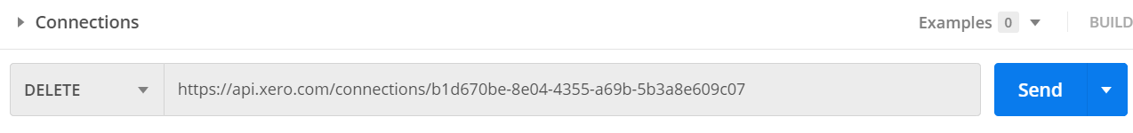

Delete the connection to the organization:

tenantID: the unique identifier for your organization in question. It can also sometimes be called organization ID. Copy ‘tenantID’ to Environment form.

Step 8: Get invoices

**Workflow Max AIP (Postman)**

Step 1: Import the Xero OAuth2.0 collection and Xero environment into Postman.

<https://developer.xero.com/documentation/tools/postman>



Step 2: Create a new app

<https://developer.xero.com/myapps/>



Step 3: Postman - Manage Environments:

**Scopes: https://developer.xero.com/documentation/oauth2/scopes**

Xero scopes: offline_access openid profile email accounting.transactions

Workflow Max scopes: workflowman

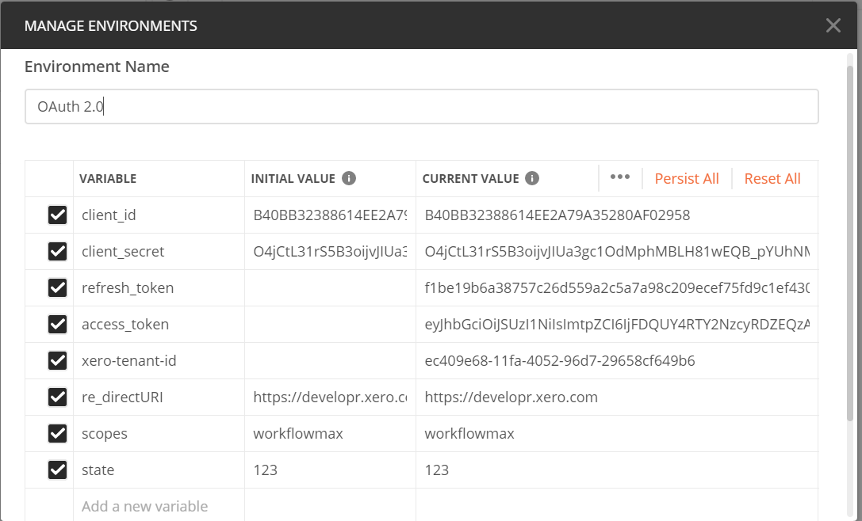

Step 4: Postman - Request token:

**Postman—Xero OAuth 2.0 – Get started – Authorization – Get New Access Token**



Access token – Highlight whole thing --Right click ‘Set OAuth 2.0’– Choose ‘access_token’.



Refresh token – Highlight whole thing -- Right click ‘Set OAuth 2.0’ – Choose ‘refresh_token’.

Step 5: Postman - Refresh token



Step 6:Postman – Connections – Get & Set Workflow Max tenanted ID

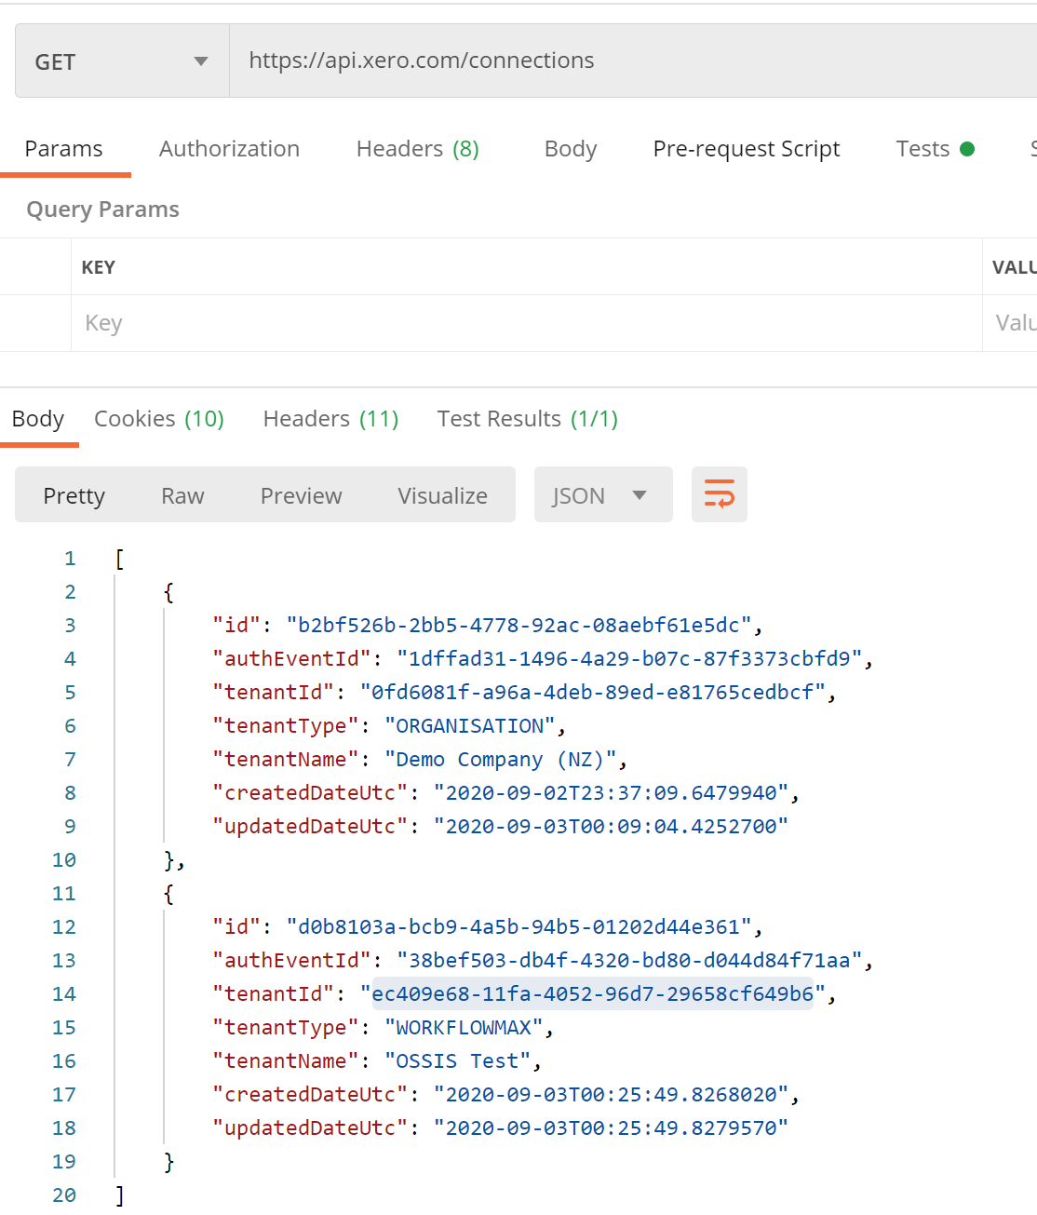 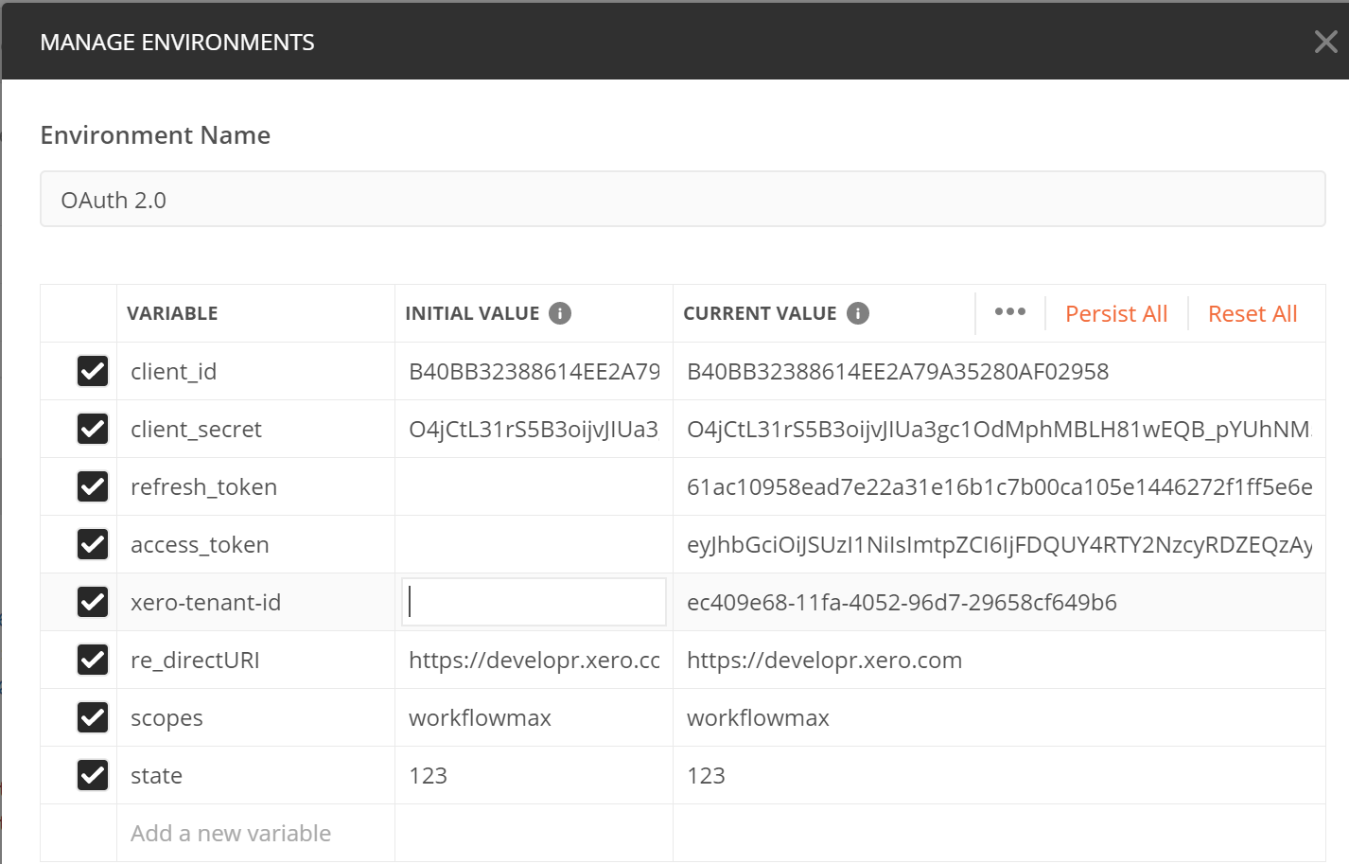

**tenantID:** the unique identifier for your organization in question. It can also sometimes be called organization ID. Copy ‘tenantID’ to Environment form.

**Step 7: Postman – Get Invoices**

<https://www.workflowmax.com/api/v3/>

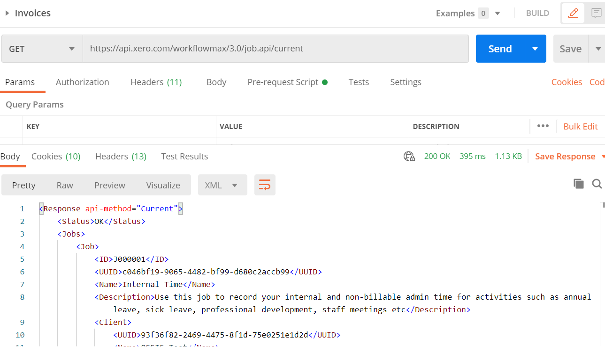

Tip: Remember to change the pass way of Get method

Put state test:

